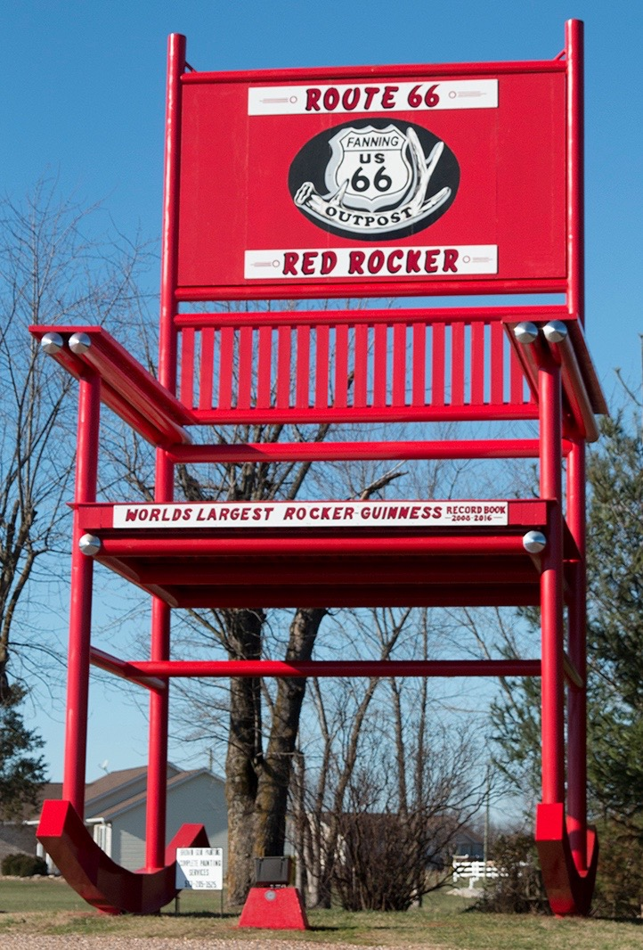

Applicants name or organization:____________________________________________________________

Address______________________________________City___________________State_______Zip___________

Contact person:________________________________________________________________________________

Contact phone number:_______________________________________________________________________

Email address:_________________________________________________________________________________

Purpose for which the funds will be used for_______________________________________________

_____________________________________________________________________________________________________________________________________________________________________________________________________________________________________________________________________________________________________________________________________________________________________________________________________________________________________________________________________________________________________________________________________________________________________________________________________________________________________________________________________________________________________________________

Who will be benefiting from the contribution:_______________________________________________

Have you ever received money from Race to the Rocker before?__________________________

Have you ever or will you be volunteering or participating in Race to the Rocker?__________________________________________________________________________________________

$ Amount requested_____________________

Date funds are needed by_______________

Applicants Signature_____________________________________Date______________________

We are happy to receive request for help with community and school projects. Because we get so many requests, all applications will be reviewed by the race staff in order to determine funding. Applications are due back to the race staff by March 24, 2018.

***2018 Race to the Rocker***

***Donation request form***

Please send all applications to:

Race to the Rocker

Attn: Tanya McKellips

662 Westbrook Rd.

Cuba, MO 65453

or

Email: [racetotherocker6@yahoo.com](mailto:racetotherocker6@yahoo.com)